**TABL E OF CONTENTS**

**CONTENTS PAGE NO**

|  |  |
| --- | --- |
| * Abstract | i |
| * Introduction | 1-1 |
| * Literature survey | 2-4 |
| * Problem statement | 4 |
| * Methodology * Simulation Model Of EV | 4-6 |
| * Components required | 6-10 |
| * Advantages | 11 |
| * Conclusion * Bibliography | 11  12 |

|  |  |  |
| --- | --- | --- |
|  |  |  |
|  |  |  |
|  |  |  |
|  |  |  |

**List of Figures**

1. EV cost and battery cost
2. Beta version of vehicles
3. Poor Infrastructure and range anxiety
4. Environmental concerns
5. Servicing is in danger

**Page no**

1

2

3

4

5

**ABSTRACT**

Electric vehicles provide to humanity as a sustainable mode of transport, but not polluting the environment, due to this the interest in electric vehicles is increasing day by day. The energy consumption values of the electric vehicles can be determined. In the same way the effect of parameters on vehicles performances and energy consumption can also be monitored. The range of electric vehicles is medium, and they can reach high speeds, in future by making use of developed electric motor and battery technology, longer distance vehicles can be manufactured. Therefore, performance of longer distance vehicles can be optimized by selecting the motors and batteries depending on the drive cycles. In these times, the dynamic model of an electric vehicle is created with MATLAB/Simulink software tool. Here we have created different models for Drive Cycle management, for modelling of EV. The variation in graphs and display lead us to different conclusions that how different drive cycles differ in each other in the simulation. We used different drive cycles sources to get our results, we simulated models for different set of time and got simulation results.

**KEYWORDS:**

Electric Vehicles (EV), Motor Torque, Vehicle Speed, State of Charge (SOC), State of energy (SOE), Battery Management System(BMS), Energy efficiency.

i

# INTRODUCTION

An EV is a shortened acronym for an electric vehicle. EVs are vehicles that are either partially or fully powered on electric power. Electric vehicles have low running costs as they have less moving parts for maintaining and also very environmentally friendly as they use little or no fossil fuels (petrol or diesel). All-electric vehicles, also referred to as battery electric vehicles (BEVs), have an electric motor instead of an internal combustion engine. Electric vehicles use electricity to charge their batteries instead of using fossil fuels like petrol or diesel. Electric vehicles are more efficient, and that combined with the electricity cost means that charging an electric vehicle is cheaper than filling petrol or diesel for your travel requirements. Compared to liquid fuels, most current battery technologies have much lower specific energy, and this often impacts the maximum all-electric range of the vehicles. The most common battery type in modern electric vehicles are lithium-ion and lithium polymer, because of their high energy density compared to their weight. Electric cars are quiet, comfortable, economic and exciting. The electric motor is smaller than an internal combustion engine translating into roomy interiors and a peaceful drive. Torque, or pulling power, is instantly available, top speeds exceed legal limits and there are no gears to grind. An electric vehicle (EV) is one that operates on an electric motor, instead of an internal-combustion (IC) engine that generates power by burning a mix of fuel and gases. Therefore, such as a vehicle is seen as a possible replacement for current-generation automobile, in order to address the issue of rising pollution, global warming, depleting natural resources, etc. Though the concept of electric vehicles has been around for a long time, it has drawn a considerable amount of interest in the past decade amid a rising carbon footprint and other environmental impacts of fuel-based vehicles. Due to combustion of oil, it will create environmental pollution problem. The cost of the batteries and motors are stable, so EV prefers than the fuel-based vehicles.

# LITERATURE SURVEY

* Thomas Parker,” **Modelling and Performance Analysis of an Electric Vehicle with MATLAB/Simulink**”, The first electric car in 1884, 25 years after the invention of lead-acid batteries. After that date, many electric vehicle models appeared. However, the development of internal combustion engine technology and the reduction in mass production costs have left electric vehicles behind.
* Sanguesa.J.A, Torres-Sanz.V, Garrido.P, Martinez. F.J, Marquez-Barja.J.M, “**A Review on Electric Vehicles: Technologies and Challenges**.” Electric Vehicle Emit Zero emissions: this type of vehicles neither emit tailpipe pollutants, CO**2**, nor nitrogen dioxide (NO2). Also, the manufacture processes tend to be more respectful with the environment, although battery manufacturing adversely affects carbon footprint.
* Nilay Awasthi, “**Designing of Electric Vehicle using MATLAB and Simulink**” Electric Vehicle comprise of various models, which are interconnected for working of the vehicle. Initially while designing an electric vehicle, one has to fix certain parameters like, radius of tires, type of motor, type of battery and the dimensions of the vehicle.
* Abhishek Gaurav, Anurag Gaur, ”**Modelling of Hybrid Electric Vehicle Charger and Study the Simulation Results** ” It is necessary that alternating sources for oil reserves that are exhaustible in future need to be found. Due to combustion of oil, it will create environmental pollution.
* G. B. Shrestha, and B. C. Chew, “**Study on the Optimization of Charge-Discharge Cycle of Electric Vehicle Batteries**” The search for the ideal electric vehicle battery is a matter of optimization to find the battery technology that will give the best combination of performance, life, and cost with adequate safety and minimum environmental impact.
* P Chatterjee, J Singh, R Singh, Y A R Avadh, and S Kanchan**, “Electric Vehicle Modeling in MATLAB and Simulink with SoC &SoE Estimation of a Lithium-ion Battery”** Have beenvalidated the connection between battery’s State of Charge - SOC and State of Estimation – SOE for lithium-ion battery under many working conditions.
* Shivangi Kaushik **“Modelling and Simulation of Electric Vehicle to Optimize Its Cost and Range”,** Due to the uses of fuels in the vehicles Co2 gas dissipated in the large amount. The carbon dioxide gas effect the environment very badly. The CO**2** reduction is the main challenge, and it can be achieved by the Eco-friendly vehicle or car called Electric vehicle (EV). The EVs are very economical due to their driven process achieved by an electric motor**.**

**PROBLEM STATEMENT**

1. **EV cost and battery cost:** The cost is the most concerning point for an individual when it comes to buying an electric vehicle. However, there are many incentives given off by central and state governments. But the common condition in all policies is that the incentives are only applicable for up to a certain number of vehicles only and after removing the discount and incentives the same EV which was looking lucrative to buy suddenly becomes unaffordable. This tells that buying EV’s no more be cheaper after a certain saturation point.

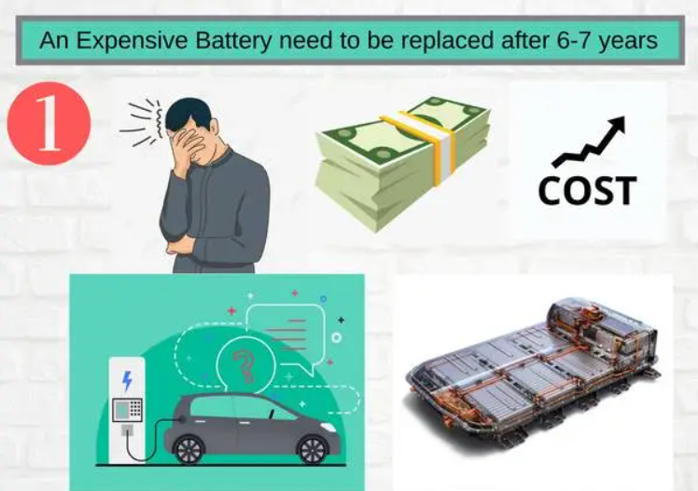

Fig1: EV cost and battery cost

### Beta version of vehicles: Right now, both the technology and companies are new to the market and the products they are manufacturing are possibly facing real costumers for the first time. And it’s nearly impossible to make such a complex product like an automobile perfect for the customers in the first go, and as expected the buyers faced many issues. Vehicles like [RV400](https://evehicleshop.in/revolt-rv400-full-specifications-and-user-review/), [EPluto-7G](https://evehicleshop.in/pure-ev-epluto-7g/), Nexon all them has to update their vehicle up to a very high extent after customer feedback and reviews.

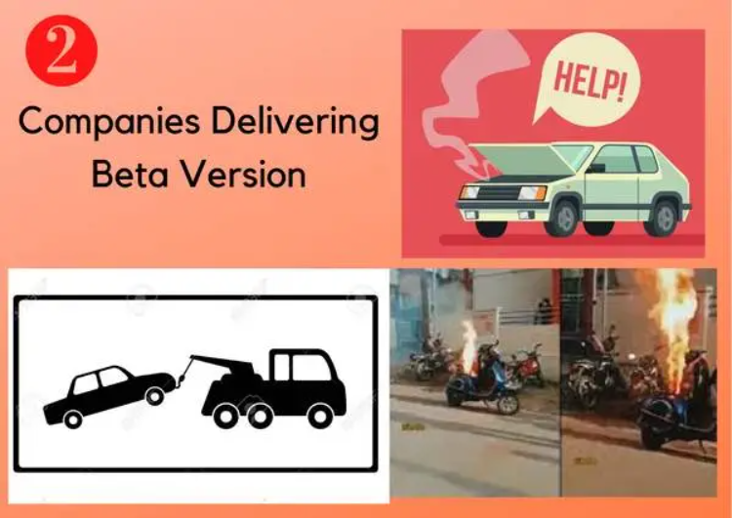

Fig2: Beta version of vehicles

Recently Pure EV has made a lot of changes in their policies, software, hardware, and not even Tata motors has to upgrade their BMS and regen software after a lot of complaints from the customers regarding extremely low range. So, buying the vehicle from the first batch of the company’s production would be a bad idea and can even give you an extremely bad experience.

### Poor Infrastructure and range anxiety: Poor infrastructure is among the most pressing issue among people thinking to opt for electric vehicles. Poor infra doesn’t only include a lack of charging stations but also the lack of proper charging set up in their home. Charging a heavier electric car could be a major problem for any electric car owner if he/she lacks proper setup (Powerful MCB, wire, and earthing) near their place.

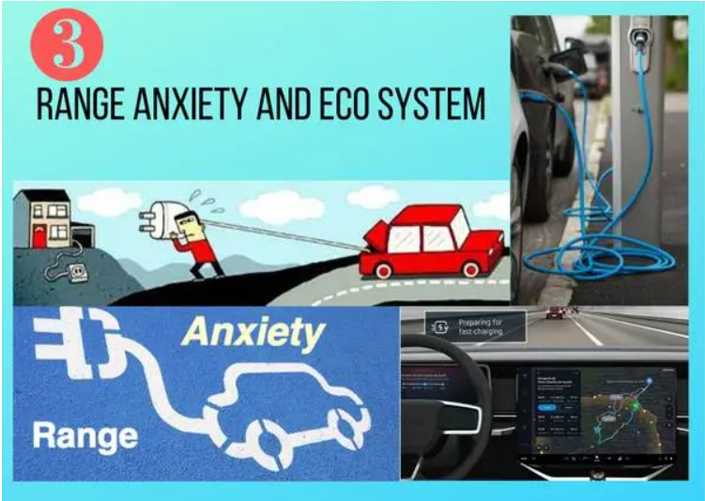

Fig3: Poor Infrastructure and range anxiety

**Range anxiety:** This problem of mental pressure comes due to lack of charging infrastructure which is improving day by day but still required to improve a lot in this area.

### Environmental concerns: The EV revolution is necessary for the most populated and polluted parts of India like Delhi, Mumbai, etc. but in such cities the major chunk of electricity is generated through burning fossil fuels which are equivalent to spreading the pollution through the ICE vehicle smoke, even most of the charging stations are reportedly operating upon diesel-driven electricity generator.

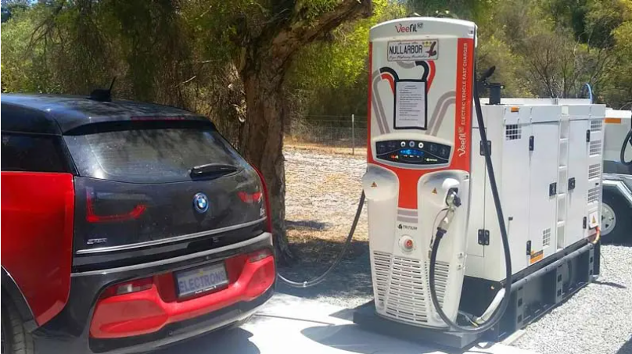

Fig4: Environmental concerns

So, the only solution to the emission problem is to use renewable energy sources. (Like Solar power, wind energy, tidal power, etc).

### Servicing is in danger: Servicing and spare parts are some of the most important parts for any vehicle, especially for vehicles facing Indian roads. Also, the quality of material offered in new-age electric vehicles are of very low quality and upon which the companies are adding some very high-tech functionalities like onboard GPS, touch screen panels, extremely delicate sensors. In some unfortunate period if even a light or indicators damages, you won’t have any other choice than replacing from the company itself (Which will be extremely costly). Because almost every company is using their costume made part in a highly vulnerable product like the vehicle it’ll cost a lot in a long term for the vehicle owners if even a very small defect like breaking of light takes place.

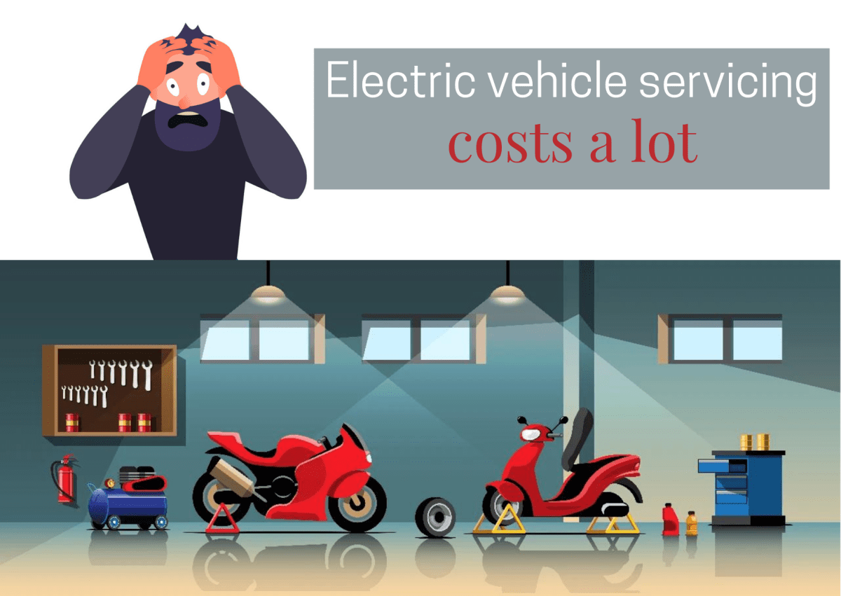

Fig5: Servicing is in danger

**METHODOLOGY**

**General blocks of Electric Vehicle have been represented in the diagram given below,**

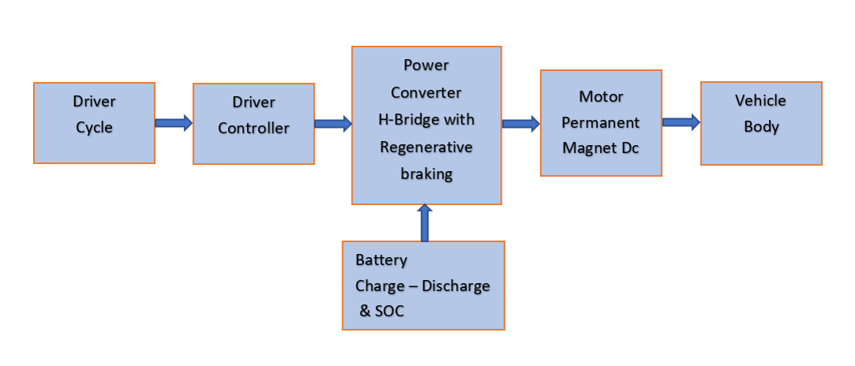

* **Drive cycle:** This is the input given to the vehicle. There are different types of drive cycle based on the application we choose. In this vehicle is simulated for acceleration & deceleration for a particular type with the varying speed range.
* **Driver controller:** To drive the drive cycle as per the given condition, a driver controller is present to run the vehicle taking the input and feedback from to move from one place to another.
* **Power Converter:** They are used to process and control the flow of electrical energy by supplying required voltages and current in a form that is optimally suited for the user loads.
* **Battery:** This the powerhouse which supplies the energy required to drive the vehicle.
* **Motor:** It is the rotating device which converts the electrical energy in the form of current and voltage into the mechanical energy at the vehicle through a transmission system.
* **Vehicle body:** This is where the output is achieved via the motor power is transferred to the wheel considering the different forces and resistance and compare with the input drive cycle.
* NO Internal Combustion Engine
* Only electric drive
* Battery pack size is (20-80 kwh)
* Example: Tesla, Nissan, Kia, etc…

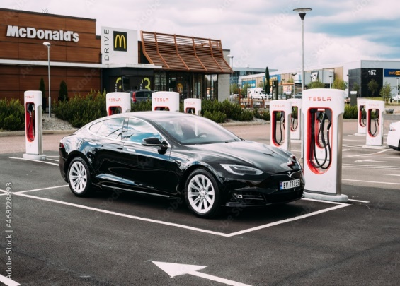

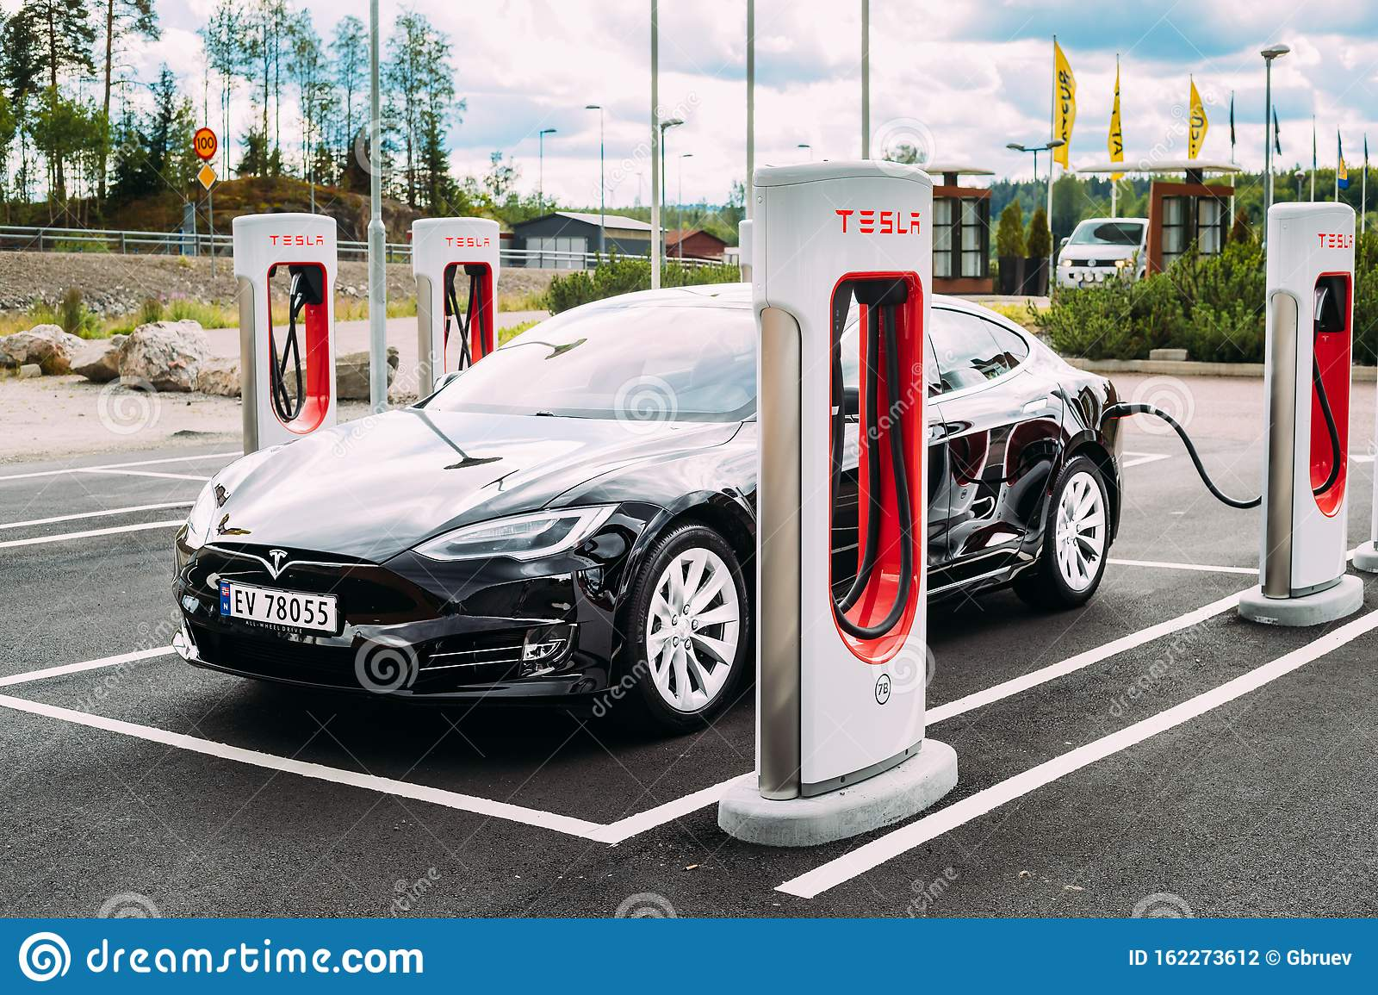

The charging of electric vehicles (EVs) through EV charging systems, including their associated infrastructure, whose GHG emission reductions are achieved through the displacement of emissions from conventional fossil fuel vehicles used for passenger and freight transportation as a result of the electricity delivered by the project chargers. It provides easy-to-use monitoring parameters to quantify emission reductions, and also establishes default factors for the estimation of certain parameters for projects located in the United States and Canada as an alternative to project-specific calculations. This is applicable globally, and provides a positive list for determining additionality for regions with less than five percent market penetration of electric vehicles. The positive list is found in Activity Method for Determining Additionality of Electric Vehicle Charging Systems. It’s applying to project activities which install EV charging systems, including their associated infrastructure, in order to charge EV applicable fleets whose Green-House Gas (GHG) emission reductions are achieved through the displacement of conventional fossil fuel vehicles used for passenger and freight transportation as a result of the electricity delivered by project chargers.

**HARDWARE REQUIREMENTS**

**Tire [Magic Formula]** The longitudinal behavior of a highway tire characterized by the tire Magic Formula.

1. Connection A is the mechanical rotational conserving port for the wheel axle.
2. Connection H is the mechanical translational conserving port for the wheel hub.
3. Connection N is a physical signal input port that applies the normal force acting on the tire.
4. 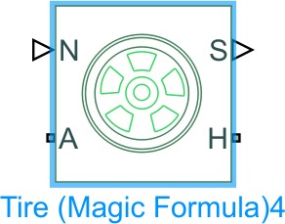Connection S is a physical signal output port that reports the tire slip.

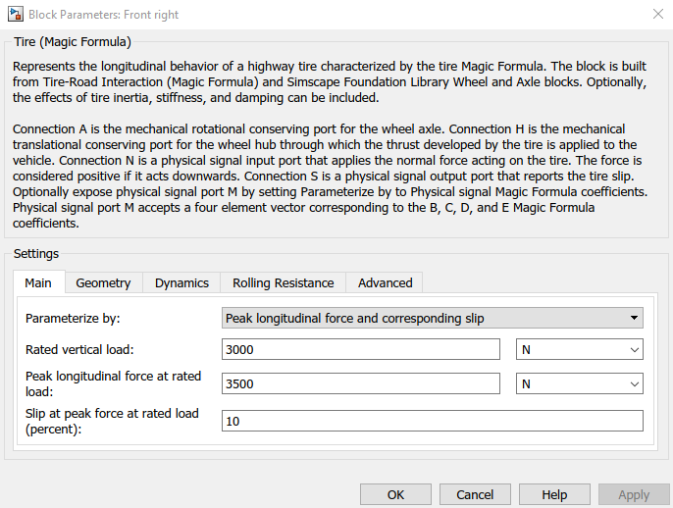

Figure 6: Tire[Magic Formula]

**Simple Gear** Represents a fixed-ratio gear or gear box.

1. Connections B (base) and F (follower) are mechanical rotational conserving ports
2. 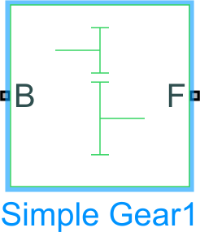expose thermal conserving port H by setting Friction model to a temperature-dependent setting.

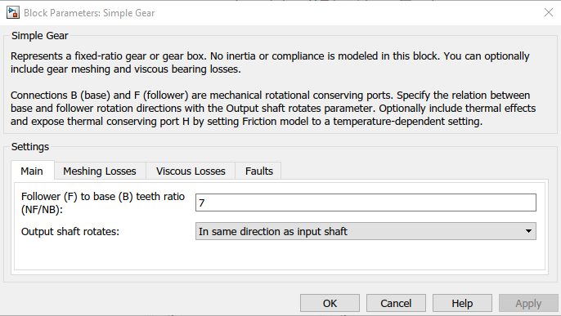

Figure 7: Simple Gear

**Vehicle Body** Represents a two-axle vehicle body in longitudinal motion.The block accounts for body mass, aerodynamic drag, road incline, and weight distribution between axles due to acceleration and road profile. The vehicle does not move vertically relative to the ground.

1. Connection H is the mechanical translational conserving port associated with the horizontal motion of the vehicle body.
2. Connections V, NF, and NR are physical signal output ports for vehicle velocity and front and rear normal wheel forces, respectively.
3. 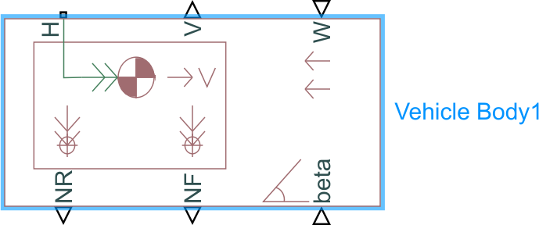Connections W and beta are physical signal input ports corresponding to headwind speed and road inclination angle, respectively.

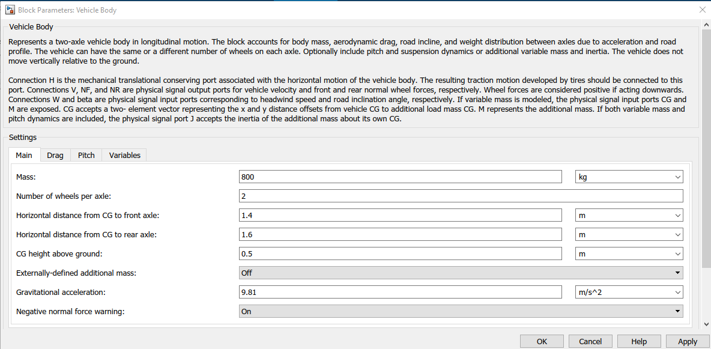

Figure 8: Vehicle Body

**Shaft Inertia**

The block represents an ideal mechanical rotational inertia. The block has one or two mechanical rotational conserving ports. The difference is purely graphical, as the ports are rigidly linked. The block positive direction is from its port to the reference point. This means that the inertia torque is positive if the inertia is accelerated in the positive direction.

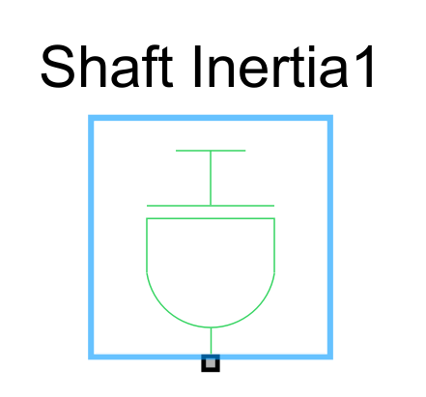

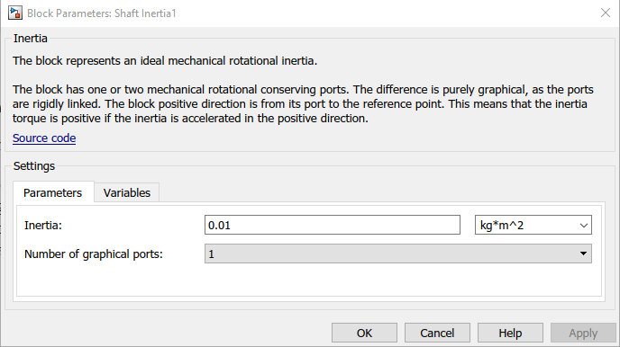

Figure 9: Shaft Inertia

# Vehicle Subsystem Internal.

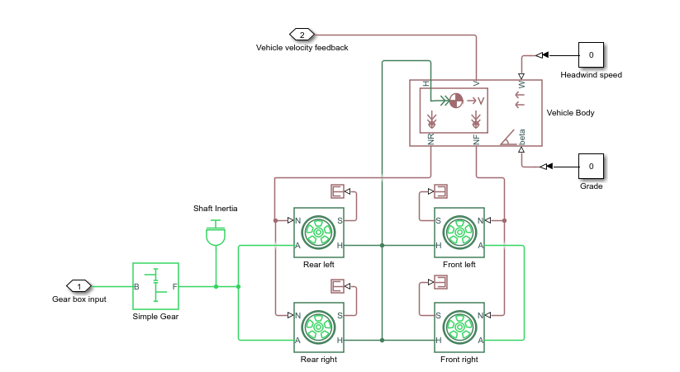

Figure 10: Vehicle Subsystem Internal

# Vehicle Subsystem.

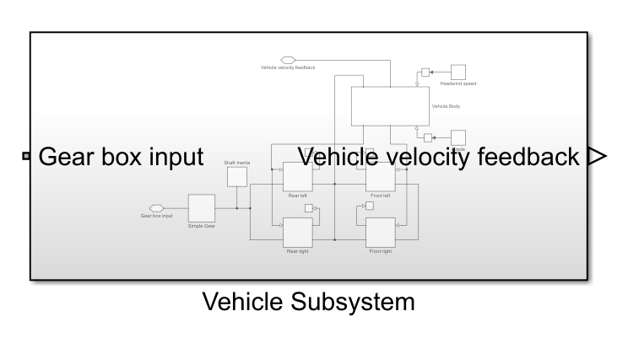

Figure 11: Vehicle Subsystem

**SOC input**

Provide an input port for a subsystem or model. For Triggered Subsystems, 'Latch input by delaying outside signal' produces the value of the subsystem input at the previous time step. For Function-Call Subsystems, turning 'On' the 'Latch input for feedback signals of function-call subsystem outputs' prevents the input value to this subsystem from changing during its execution. The other parameters can be used to explicitly specify the input signal attributes.

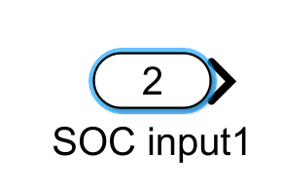

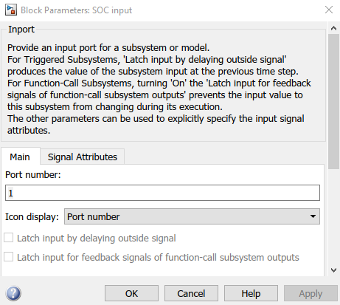

Figure 12: SOC input

**Rate Transition**

Handle data transfer between different rates and tasks.

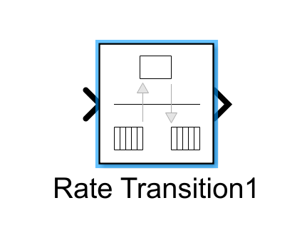

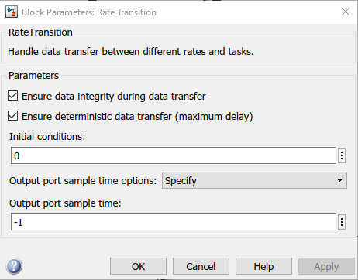

Figure 13: Rate Transition

**Discrete-Time Integrator**

Discrete-time integration or accumulation of the input signal.

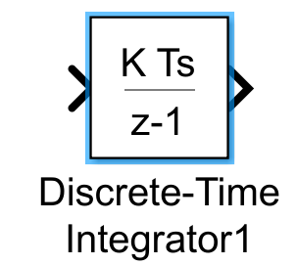

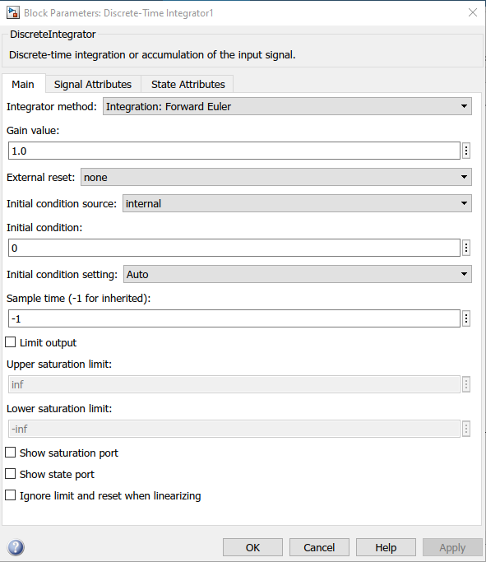

Figure 14: Discrete-Time Integrator

# SOC Subsystem Internal.

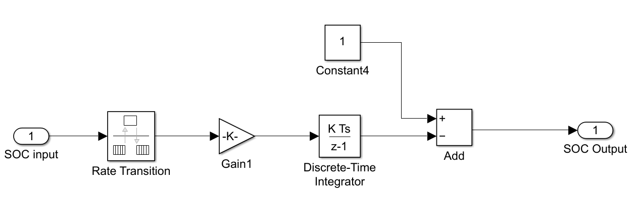

Figure 15: SOC Subsystem Internal

**SOC Subsystem.**

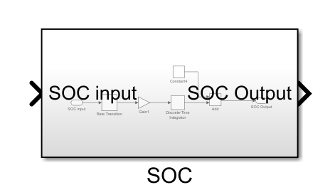

Figure 16: SOC Subsystem

**DC Moter** The electrical and torque characteristics of a DC motor. Here No electromag- netic energy is lost, and hence the back-emf and torque constants have the same numerical value when in SI units. If no information is available on armature inductance, this parameter can be set to some small non-zero value.

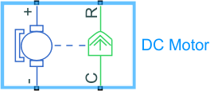When a positive current flows from the electrical + to - ports, a positive torque acts from the mechanical C to R ports.

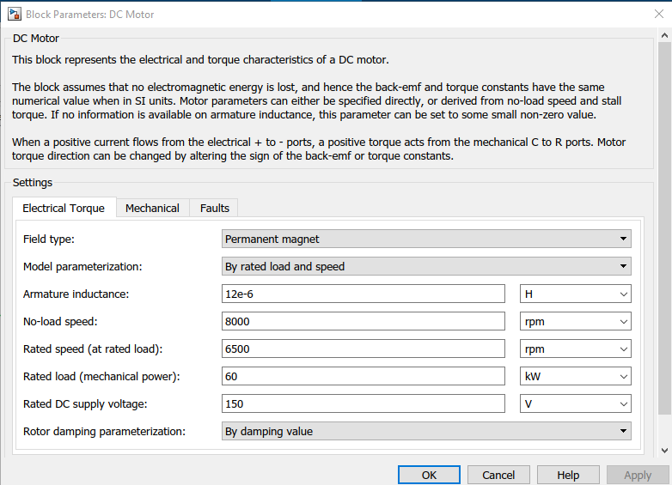

Figure 17: DC Moter

**H-bridge motor drive** Controlled PWM Voltage block in PWM or Averaged mode. In PWM mode, the motor is powered if the PWM port voltage is above the Enable threshold voltage. In Averaged mode, the PWM port voltage divided by the PWM signal amplitude parameter defines the ratio of the on-time to the PWM period.

If the BRK port voltage is greater than the Braking threshold voltage, then the output terminals are short circuited via one bridge arm in series with the parallel combination of a second bridge arm and a freewheeling diode. Voltages at ports PWM, REV and

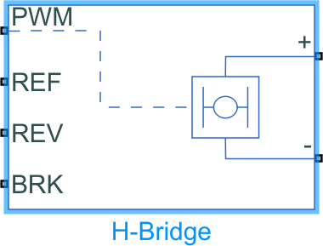BRK are defined relative to the REF port.

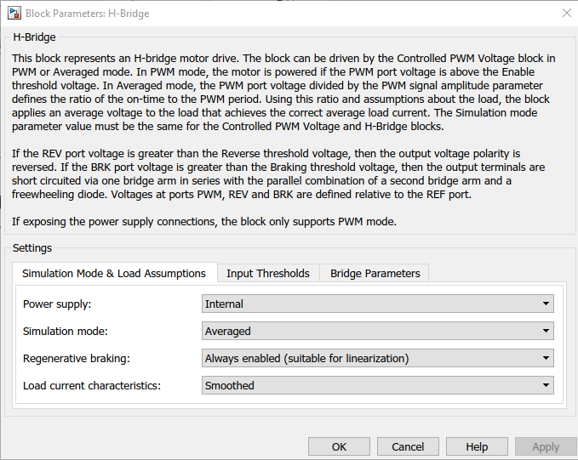

Figure 18: H-bridge motor drive

**Ground (Mechanical Rotational Reference)** Ground it to connect mechanical rotational ports that are rigidly affixed to the frame.

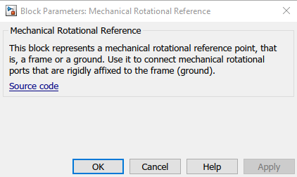

Figure 19: Mechanical Ground

**Controlled (PWM) voltage** PWM voltage across the PWM and REF ports.The output voltage is zero when the pulse is low, and is equal to the Output voltage amplitude parameter when high.

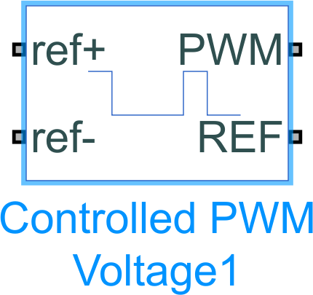At time zero, the pulse is initialized as high unless the duty cycle is set to zero or the Pulse delay time is greater than zero.

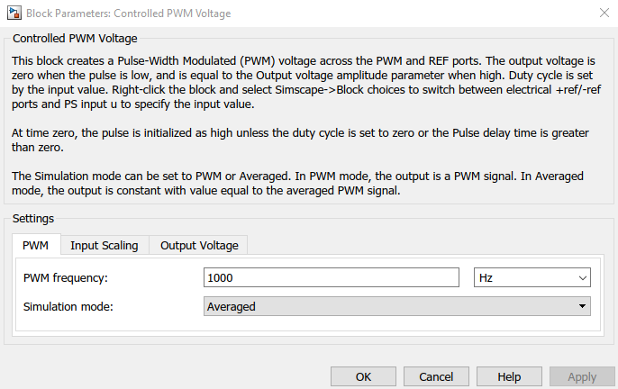

Figure 20: PWM voltage

**Controlled voltage source** An ideal voltage source that is powerful enough to maintain the specified voltage at its output regardless of the current passing through it. The output voltage is V = Vs.

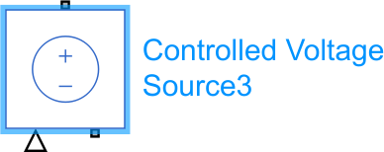

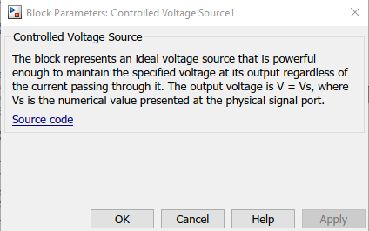

Figure 21: Controlled voltage

**Electrical reference port** A model must contain at least one electrical reference port.

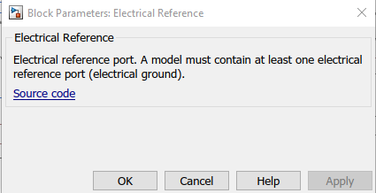

Figure 22: reference port

**longitudinal Driver** longitudinal speed tracking controller for generating normalized acceleration and braking commands based on reference and feedback velocities.

The external actions to input signals that can disable, hold, or override the closed-loop commands determined by the block.

* VelRef — Reference vehicle velocity scalar
* VelFdbk — Longitudinal vehicle velocity scalar
* Grade — Road grade angle
* Info — Bus signal
* DecelCmd — Commanded vehicle deceleration
* 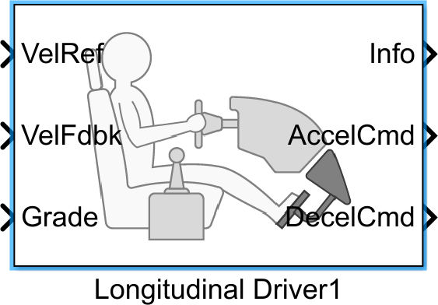AccelCmd — Commanded vehicle acceleration

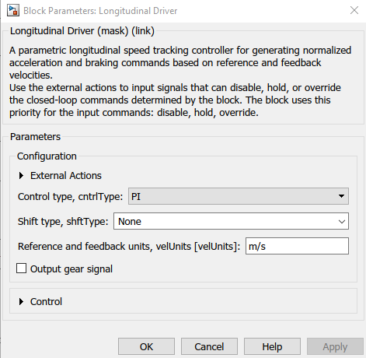

Figure 23: longitudinal Driver

**Simulink-PS-Converter** Converts the Simulink input signal to a Physical Signal.

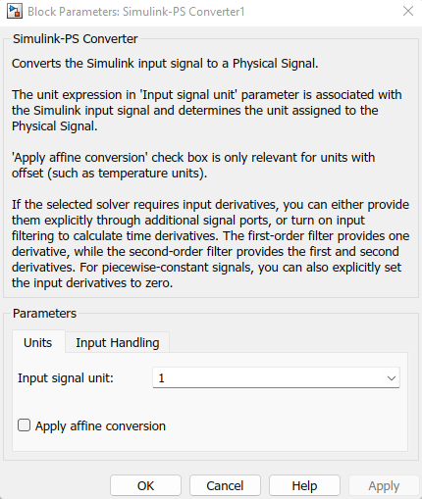

Figure 24: Simulink-PS-Converter

**PS-Simulink-Converter** Converts the input Physical Signal to a Simulink output signal.

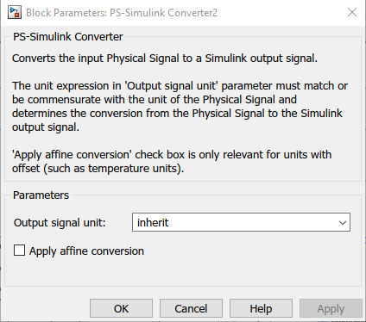

Figure 25: PS-Simulink-Converter

**Constant** Constant specified by the ’Constant value’ parameter. If ’Constant value’ is a vector and ’Interpret vector parameters as 1-D’ is on, treat the constant value as a 1-D array. Otherwise, output a matrix with the same dimensions as the constant value.

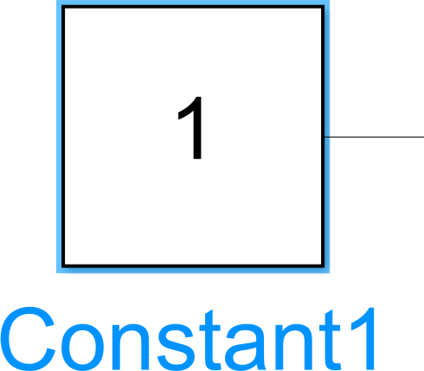

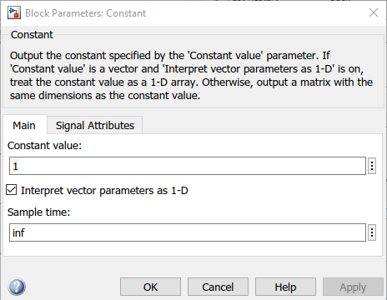

Figure 26: Constant

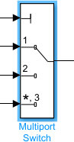**Multiport Switch** The input signals corresponding to the truncated value of the first input. The inputs are numbered top to bottom (or left to right). The first input port is the control port. The other input ports are data ports.

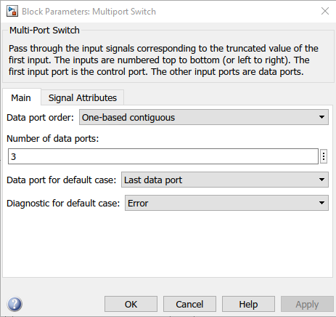

Figure 27: Multiport Switch

**Drive cycle** Generates a standard or user-specified longitudinal drive cycle. The block output is the vehicle longitudinal speed. You can import drive cycles from:

1. Predefined sources
2. Workspace variables, including arrays and time series objects
3. mat, xls, xlsx, or txt files Use the fault tracking parameters to identify drive cycle faults within specified speed and time tolerances.

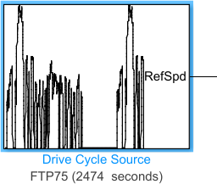

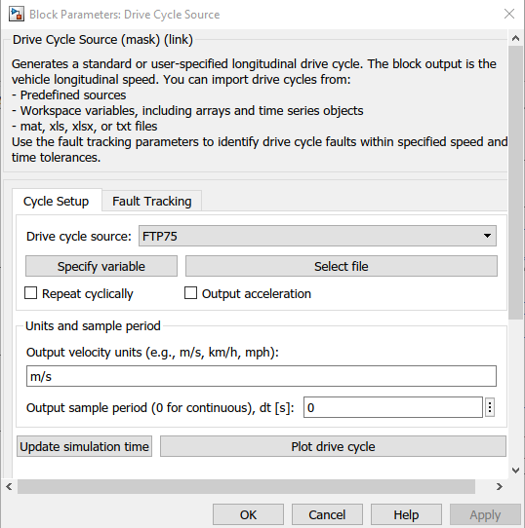

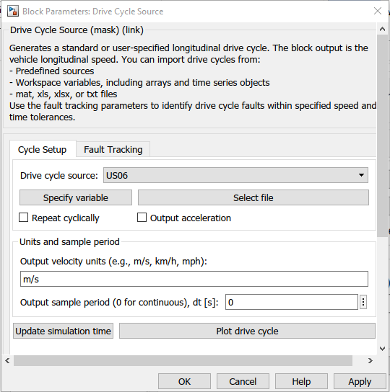

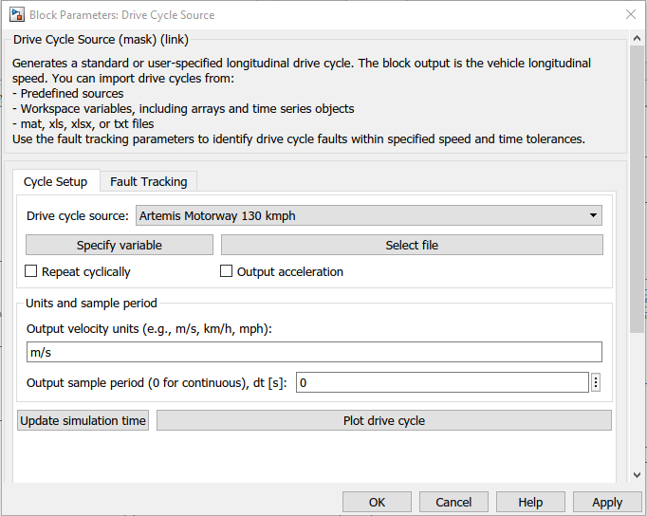

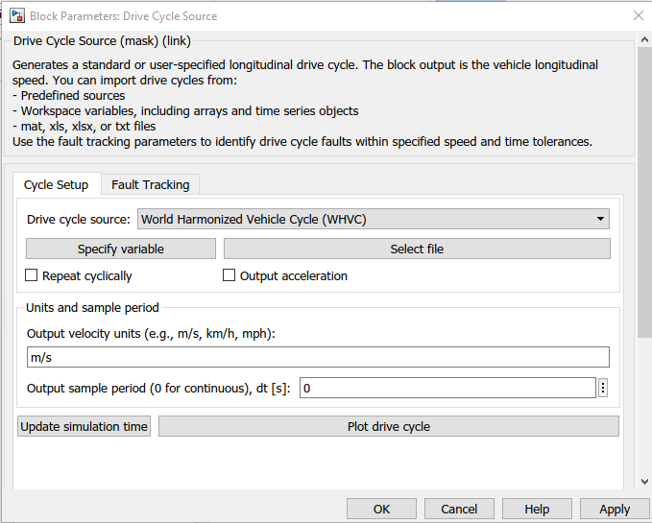

Figure 28: Drive cycle Referance

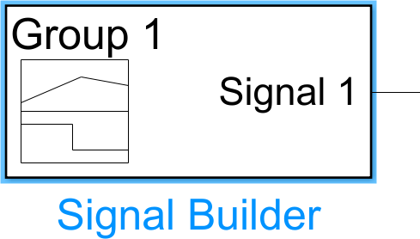**Signal Builder** It will allows us to create interchangeable groups of piecewise linear signal sources and use them in a model. You can quickly switch the signal groups into and out of a model to facilitate testing. In the Signal Builder window, create signals and define the output wave-forms. To open the window, double-click the block.

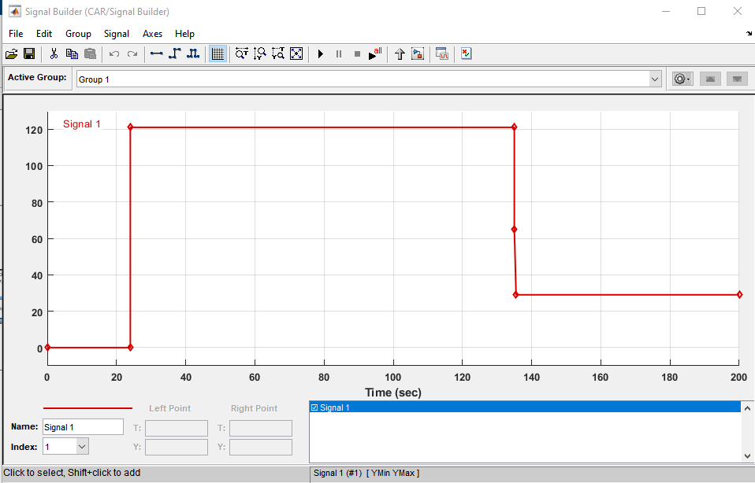

Figure 29: Signal Builder

**Scope** It can access most signals inside the model hierarchy, including referenced models and State flow charts.

Figure 30: Scope

**Current sensor** an ideal current sensor, that is, a device that converts current measured in any electrical branch into a physical signal proportional to the current.

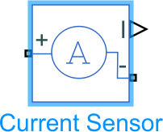Connections + and - are conserving electrical ports through which the sensor is inserted into the circuit. Connection I is a physical signal port that outputs current value.

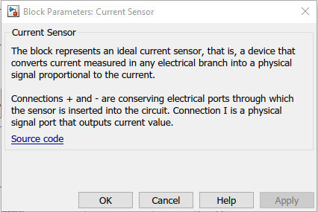

Figure 31: Signal Builder

**Battery** This block models a battery. If we select Infinite for the Battery charge capacity parameter, the block models the battery as a series internal resistance and a constant voltage source. If we select Finite for the Battery charge capacity parameter, the block models the battery as a series internal resistance plus a charge-dependent voltage source.

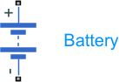Defined by: **V = Vnom*SOC/(1-beta*(1-SOC))**

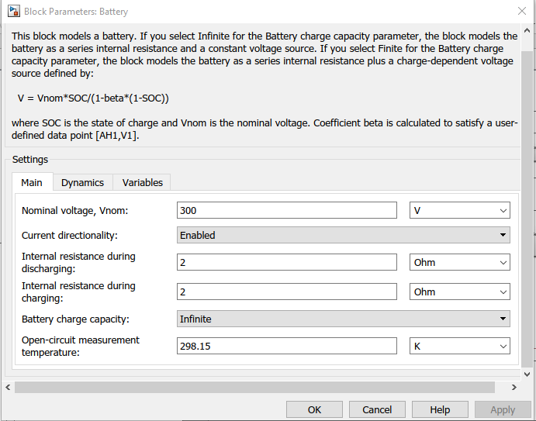

Figure 32: Battery

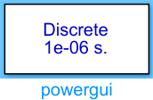**Power GUI** Set simulation type, simulation parameters, and preferences.

Figure 33: Power GUI

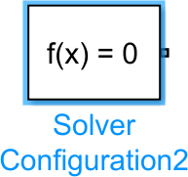**Solver Configuration** Defines solver settings to use for simulation.

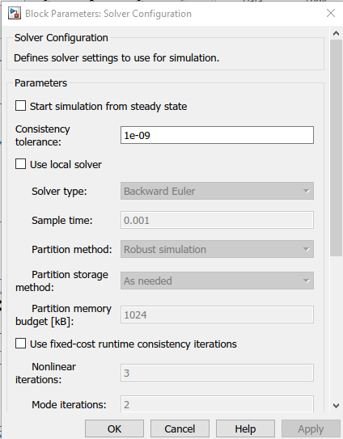

Figure 34: Solver Configuration

**Controlled Current Source** It represents an ideal current source that is powerful enough to maintain the specified current through it regardless of the voltage across it. The output current is I = Is,where Is is the numerical value presented at the physical signal port.



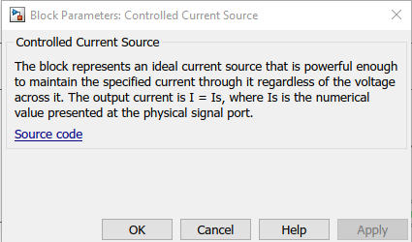

Figure 35: Controlled Current Source

**Multiply** Element-wise gain or matrix gain **(y = K*u or y = u*K).**

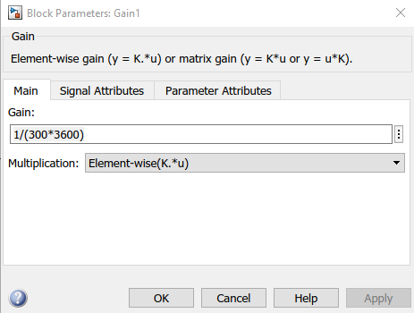

Figure 36: Multiply

**Integrator** Continuous-time integration of the input signal.

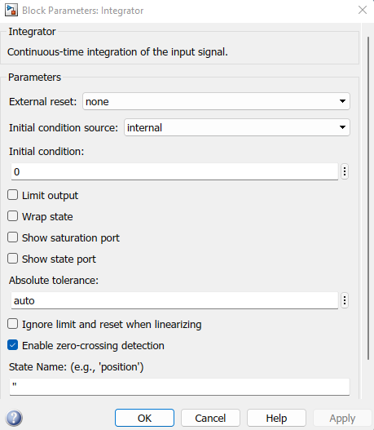

Figure 37: Integrator

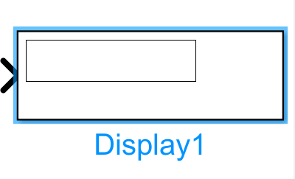**Display** Display input values. If the incoming signal is of type string, the ‘Numeric display format’ parameter selection does not affect the display of the string.

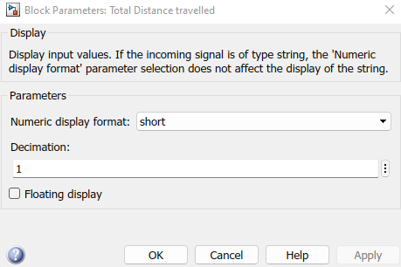

Figure 38: Display

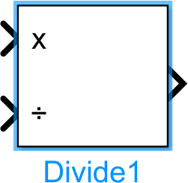**Divide** Divide or Multiply inputs performs the operation ’u1*u2/u3*u4’. and A scalar value specifies the number of input ports to be multiplied.

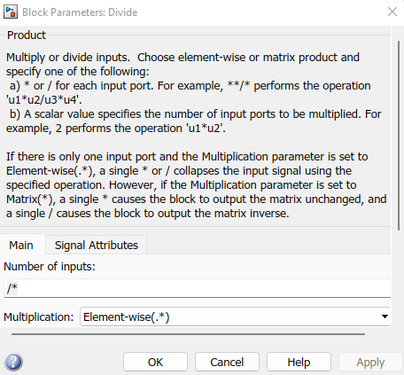

Figure 39: Divide

**SOFTWARE REQUIREMENTS**

Software: MATLAB/Simulink

Version: R2021a

The above mentioned are modelled and simulated using MATLAB/Simulink.

Software Input tool are Drive Cycle, Signal Builder, Multiport Switch, Longitudinal Driver, Controlled Voltage Source, Controlled PWM Voltage, Controlled PWM Voltage, Controlled Voltage Source H-Bridge, Current Sensor, DC Motor, SOC, Vehicle Subsystem.

Software Output tool are Scope, Total Distance travelled.

These tools are use to understand and visualization of performance of the electric vehicle[EV].

**SIMULATION MODEL OF EV**

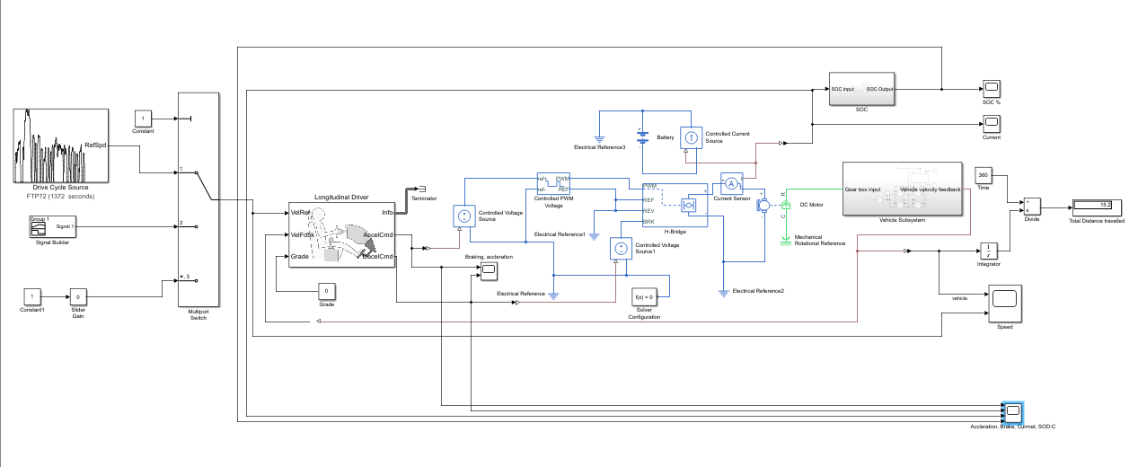

**RESULTS CASE**

The simulations are run for various drive cycles and the results are in the following table.

**Simulation Time** - It is the time for which the simulation is run. Each drive cycle has its own time duration which needs to be updated in simulation time, each time the drive cycle is changed.

**Speed Trace** - It is a plot of the reference speed from the drive cycle and the feedback speed from the vehicle body.

**SOC (%)** - It is the state of charge of the battery which decreases when the vehicle accelerated and slightly increases when the vehicle decelerates.

**Distance Travelled** - It is the total distance travelled by the vehicle following a particular drive cycle and its duration.

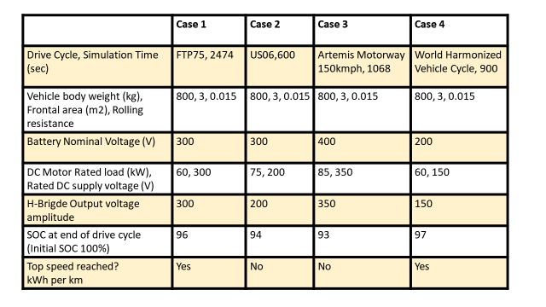

Case1: FTP75

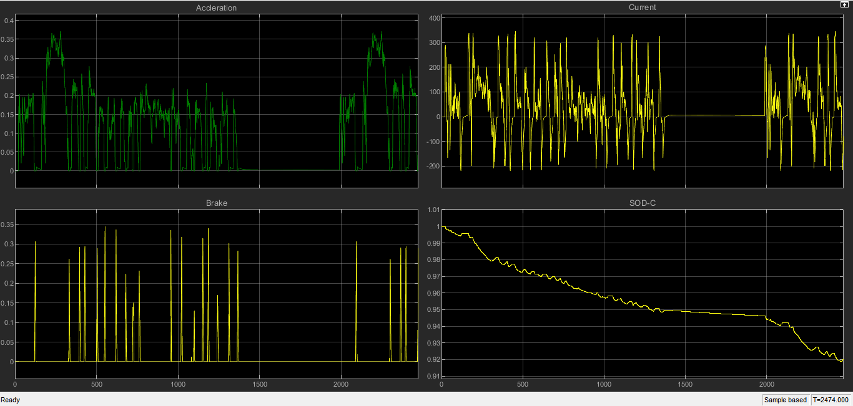

Fig shows: Acceleration, Brake, Current, Sod-c

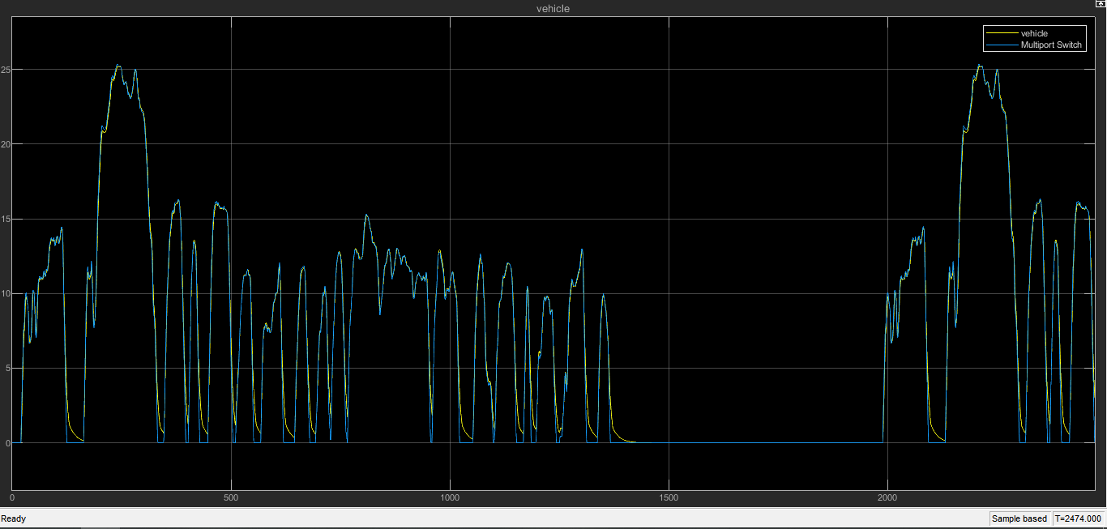

Fig shows: Reference with Vehicle

Case2: US06

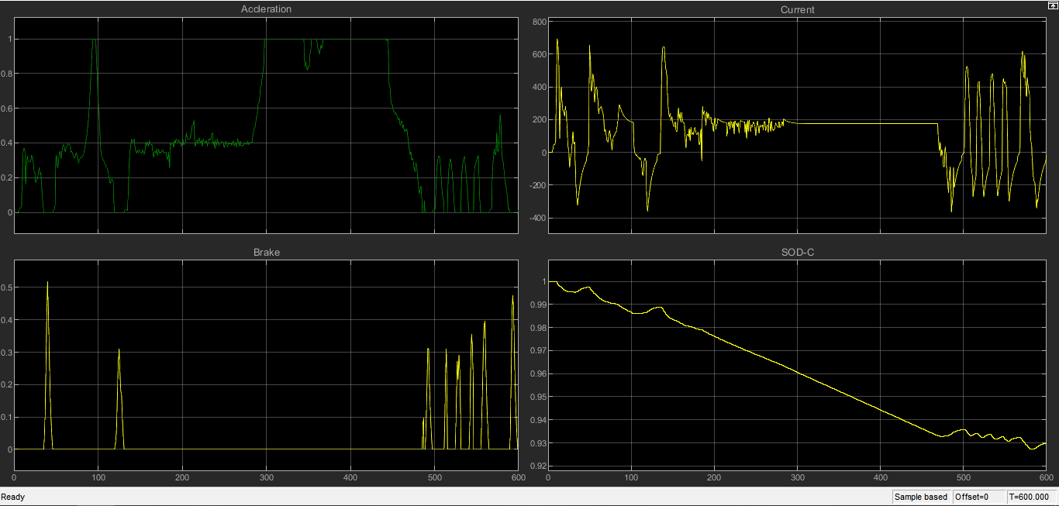

Fig shows: Acceleration, Brake, Current, Sod-c

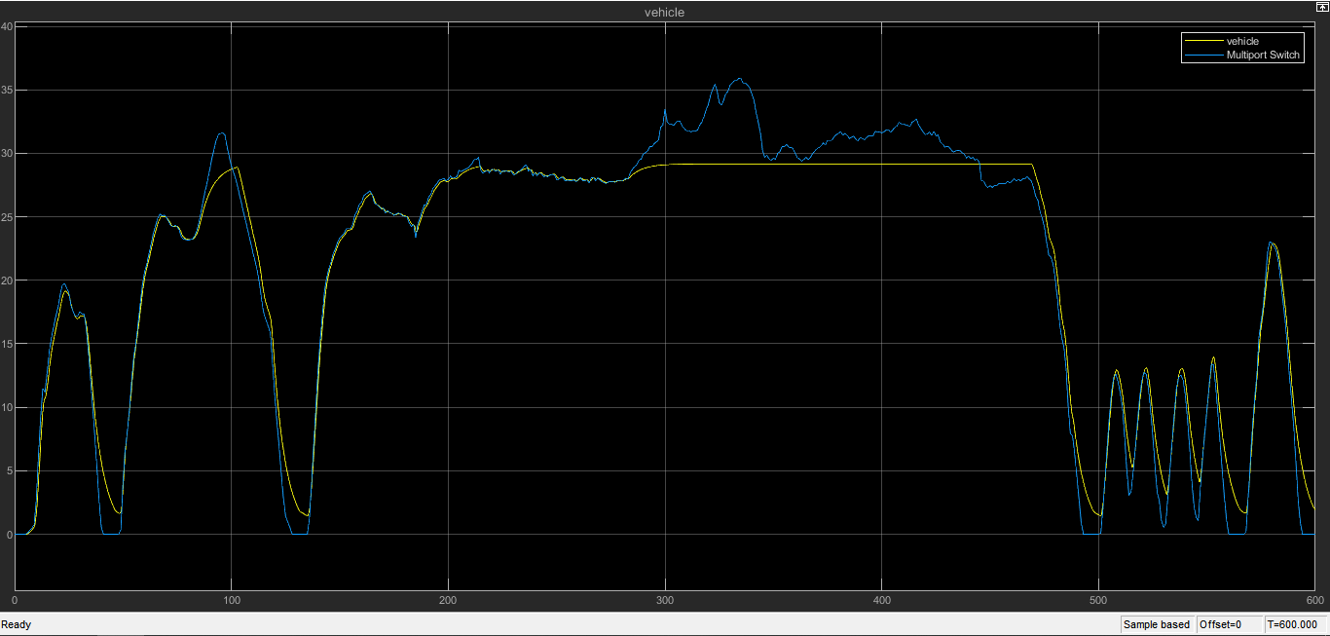

Fig shows: Reference with Vehicle

Case3: Artemis Motorway 150kmph

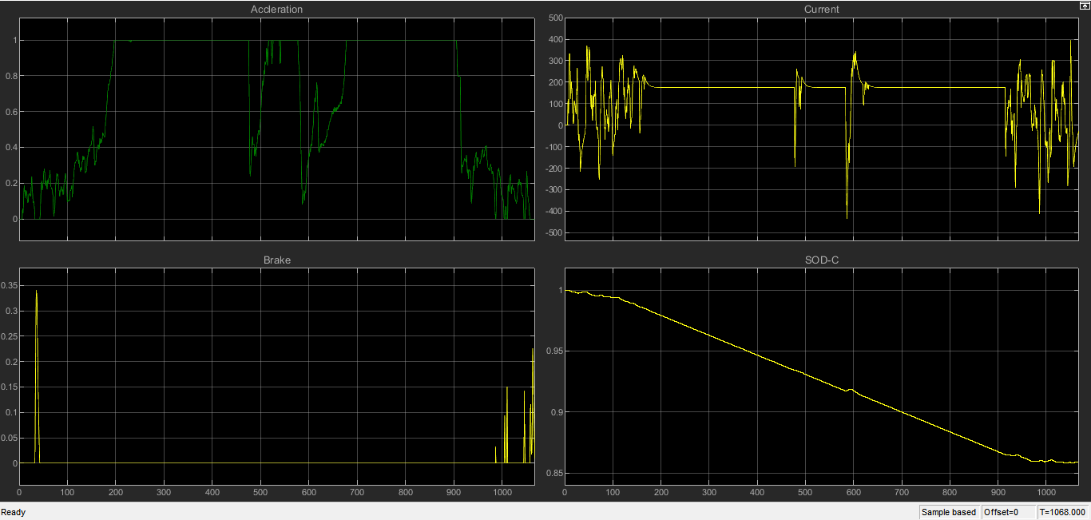

Fig shows: Acceleration, Brake, Current, Sod-c

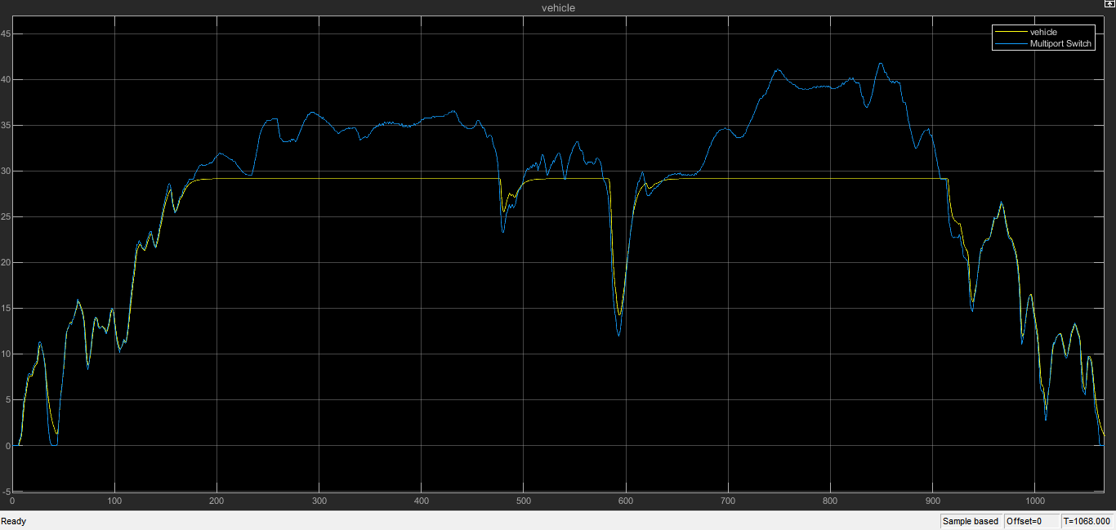

Fig shows: Reference with Vehicle

Case4: World Harmonized Vehicle Cycle

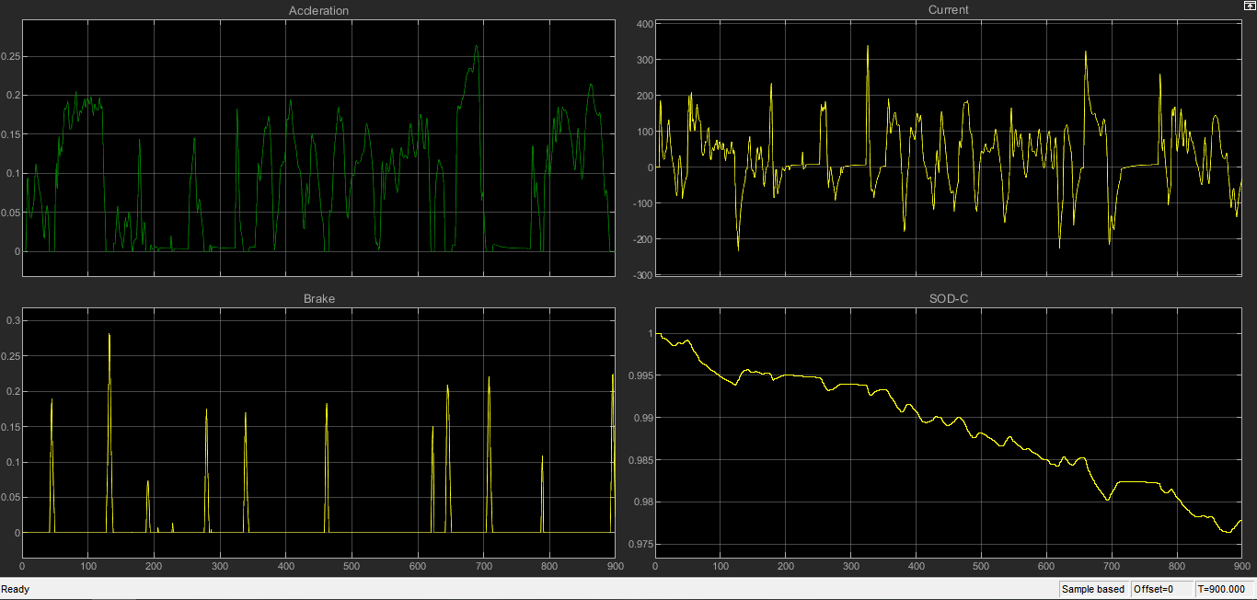

Fig shows: Acceleration, Brake, Current, Sod-c

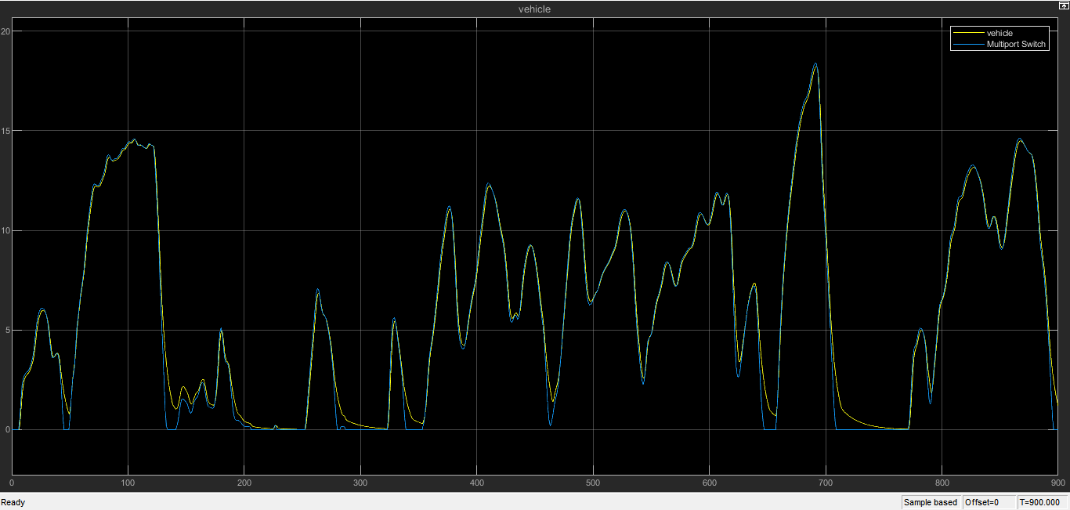

Fig shows: Reference with Vehicle

**FUTURE WORK**

* As electric vehicle manufacturing is becoming popular every day, its market share is also expected to rise greatly.
* India is expected to grow by an amazing 50% by 2023.
* It is estimated that almost 75-80% of fuel expenses are reduced by using Evs.
* Currently, 82% of the oil demand in India is fulfilled by import.
* The best part is that, apart from reducing environmental pollution, EVs can lower oil import by about $60 Billion by 2030
* Surprisingly, the fuel price of EVs can be as low as only 1.1Rs/ km. As a result, the overall cost of about Rs 20,000 is reduced while traveling every 5000 km by an EV.

ADVANTAGES

EVs offer the following advantages over traditional vehicles:

* Simplicity: The number of Electric Vehicle (EV) engine elements is smaller, which leads to a much cheaper maintenance. The engines are simpler and more compact, they do not need a cooling circuit, and neither is necessary for incorporating gearshift, clutch, or elements that reduce the engine noise.
* Reliability: Having less, and simpler, components makes this type of vehicles have fewer breakdowns. In addition, EVs do not suffer of the inherent wear and tear produced by engine explosions, vibrations, or fuel corrosion.
* Cost: The maintenance cost of the vehicle and the cost of the electricity required is much lower in comparison to maintenance and fuel costs of traditional combustion vehicles. The energy cost per kilometer is significantly lower in EVs than in traditional.
* Comfort: Traveling in EVs is more comfortable, due to the absence of vibrations or engine noise.
* Zero emissions: This type of vehicles neither emit tailpipe pollutants, Carbon Monoioxide(CO), nor Nitrogen oxide(NO).

**APPLICATIONS**

* Fuel Price Hike.
* Easy Home Charging.
* Easy to drive.
* Environment Friendly.
* Comfortable Cabin and More Storage Options.
* Government Incentives.
* EVs are future proof Consumer Electronics.
* Consumer Electronics.
* Public Transportation.
* Aviation.
* Electricity Grid.
* Renewable Energy Storage.
* Military.
* Spaceflight.
* Wearable Technology.

**CONCLUSION**

In the speed trace plots for all the drive cycles which are observed in this study, the feedback speed plot and the reference speed plot overlap each other almost completely but there are regions where both the speeds are different. It is when the vehicle is decelerating. The reference speed plot falls sharply but the feedback speed does not. This is due to the inertia of the vehicle body. As the inertia of the vehicle body is higher, it takes a longer duration for it to decelerate. That is why the overlapping is not 100%. The battery's state of charge for each drive cycle can be visualized from the SOC plot. As long as the vehicle is accelerating the SOC is decreasing but as soon as the deceleration starts, the SOC plot goes slightly up. This is because the battery is being charged, due to regenerative braking during deceleration.

**REFERENCE**

* Hitesh s, C.Sunanda, “**Modeling and Performance Analysis of an Electric Vehicle with MATLAB**”, International Research Journal of Engineering and Technology (IRJET), Volume: 07 Issue | 06 June 2020.
* Sanguesa.J.A, Torres Sanz.V, Garrido.P, Martinez. F.J. Marquez Barja. J.M**, “A Review on Electric Vehicles: Technologies and Challenges**”, Smart Cities **2021**, 4, 372–404. <https://doi.org/10.3390/smartcities4010022> | March 2021.
* Abhishek Gaurav, Anurag Gaur, “**Modelling of Hybrid Electric Vehicle Charger and Study the Simulation Results**”, DOI:978-1-7281-7549-2/20/$31.00 ©2020 IEEE | 9 September 2020.
* G. B. Shrestha, B. C. Chew, **“The Optimization of Charge-Discharge Cycle of Electric Vehicle Batteries” |** Nanyang Technological University, Singapore.
* P Chatterjee, J Singh, R Singh , Y A R Avadh and S Kanchan “**Electric Vehicle Modeling in MATLAB and Simulink with SoC &SoE Estimation of a Lithium-ion Battery**”,| P Chatterjee et al 2021 IOP Conf. Ser.: Mater. Sci. Eng. **1116** 012103 | doi:10.1088/1757-899X/1116/1/012103.
* Shivangi Kaushik**, “Modelling and Simulation of Electric Vehicle to Optimize Its Cost and Range”,| Article** *in* International Journal of Engineering and Advanced Technology |August 2019 | uploaded by Shivangi Kaushik on 17 March 2021.
* Nilay Awasthi, “**Designing of Electric Vehicle using MATLAB and Simulink”,** Electronic copy available at: https://ssrn.com/abstract=3701771